**Viewer Persona Development - Entertainment Sector**

Pooja Joshi & E.Code [E25007]

# Overview :

# The objective of today's tasks focused on developing comprehensive viewer personas to enhance targeting strategies for content within the entertainment sector. This involves analyzing viewer data, clustering results from K-Means clustering, and summarizing insights to inform marketing strategies.

# Objective:

· To define distinct viewer personas based on viewing habits, sentiment analysis, and popularity metrics.

· To analyze data and provide actionable insights for content strategies.

# ·Assigned Task(s) :

· Task 1: Data Loading and Preparation

· Task 2: K-Means Clustering Analysis

· Task 3: Summary Statistics for Clusters

· Task 4: Report Generation

# Task Details :

**Task 1: Data Loading and Preparation**

* · **Status:** Completed
* **Details:** Loaded the cleaned dataset and prepared it for analysis. Ensured all relevant columns were in the correct format.

· **Task 2: K-Means Clustering Analysis**

* · **Status:** Completed
* **Details:** Conducted K-Means clustering on viewer data to identify distinct personas based on viewing behavior and sentiment.

· **Task 3: Summary Statistics for Clusters**

* · **Status:** Completed
* **Details:** Generated summary statistics for each cluster to analyze key metrics like popularity, attendance, and sentiment scores.

**Task 4: Visualization**

* **Status:** Completed
* **Details:** Created visualizations for key metrics across clusters. Developed bar charts to show average popularity and attendance by cluster, and scatter plots to illustrate sentiment scores versus popularity.

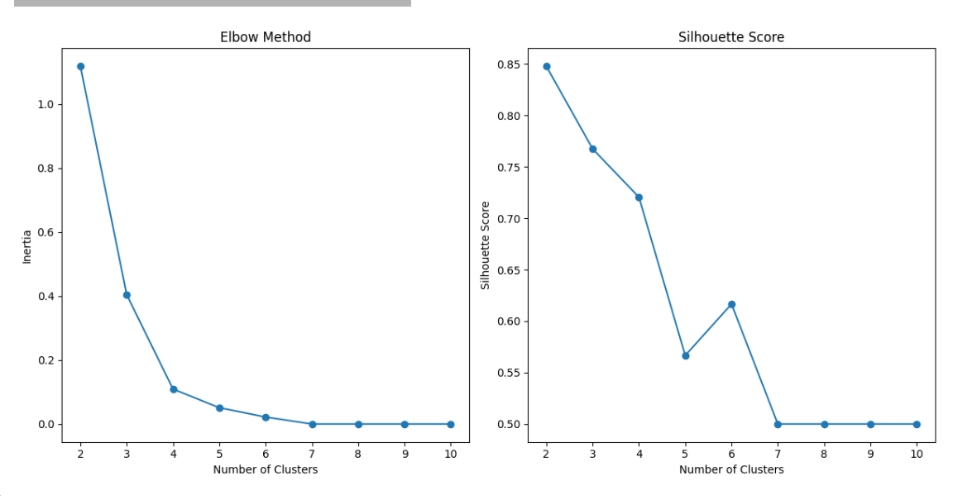

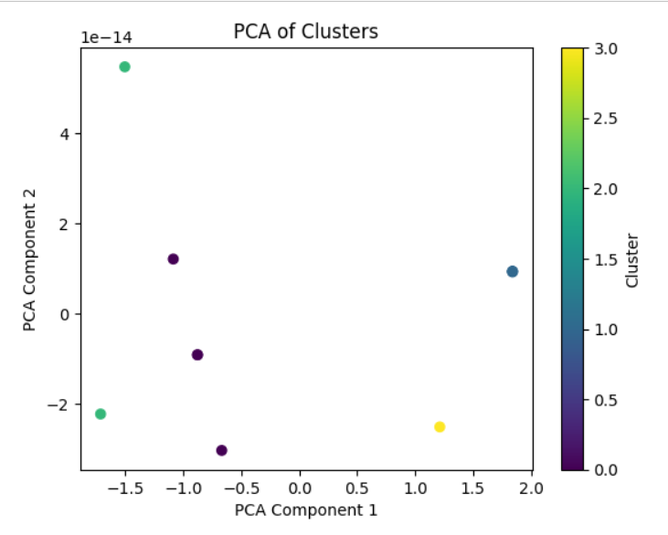

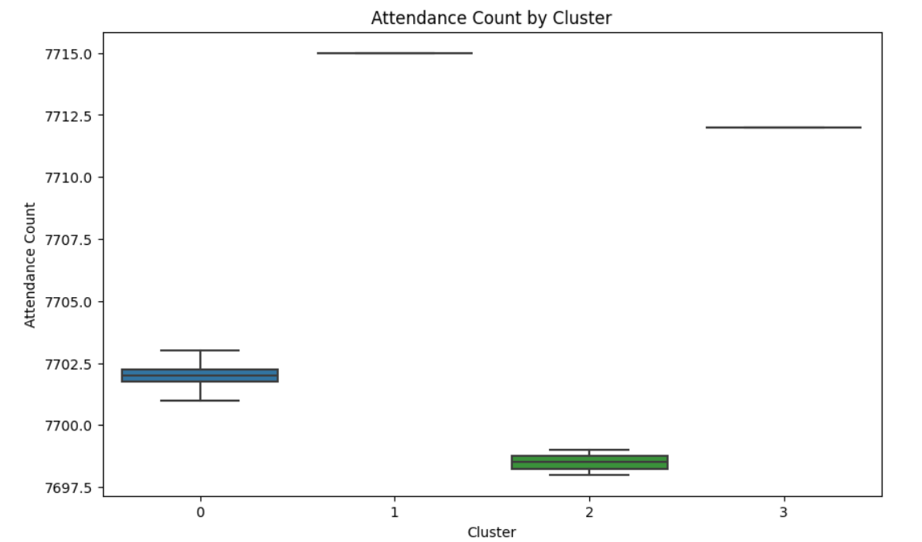

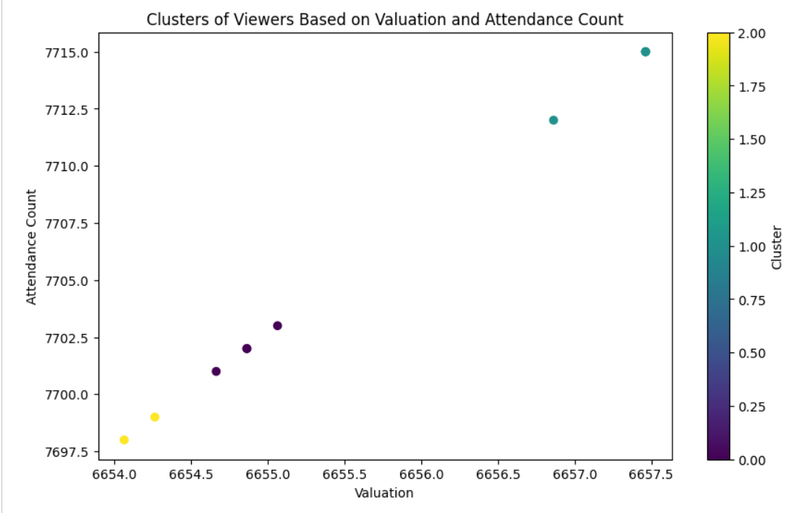

**Progress :**

· **Accomplishments:**

* Successfully performed clustering on viewer data and visualized cluster characteristics.
* Gained insights into viewer preferences and behaviors through detailed analysis and visual representation.

· **Metrics:**

* Number of clusters identified: 3
* Visuals created:
  + Bar charts comparing popularity and attendance counts across clusters.
  + Scatter plot showcasing sentiment scores versus popularity for each cluster.

# Challenges and Solutions :

· **Challenges Faced:**

* Difficulty in interpreting sentiment scores from the dataset.

· **Solutions Implemented:**

* Collaborated with team members to refine the sentiment analysis approach and ensure more accurate interpretations.

**Next Steps :**

· **Upcoming Tasks:**

* Finalize report and visuals, ensuring they effectively communicate findings.
* Review with the team and prepare a presentation for marketing strategy discussions.

· **Goals:**

* Aim to have the full report completed and reviewed by end of the week.

# Conclusion :

### Summary: Today’s work focused on developing viewer personas through data analysis, clustering, and visualizations. Key insights were generated to support future content strategies.

# **Acknowledgments**: Thank the audience for their time and attention.